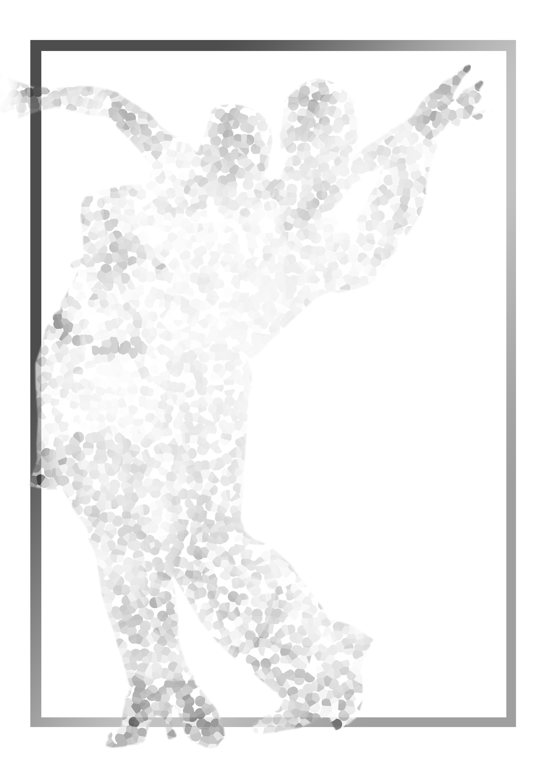

19th SGDF Singapore
National DanceSport
Championships

Sunday 15th January 2017
National University of Singapore Society (NUSS),
Kent Ridge Guild House,
9 Kent Ridge Drive,
Singapore 119241

Organised by:

Singapore DanceSport Federation

19th SGDF SINGAPORE NATIONAL DANCESPORT CHAMPIONSHIPS
Sunday 15 January 2017
National University of Singapore Society, Kent Ridge Guild House, 9 Kent Ridge Drive, Singapore 119241

Dear SGDF Member

The Singapore DanceSport Federation (SGDF) is pleased to present to you, the nineteenth (19th) in a series of local ranking championships.

TITLE: 19th SGDF Singapore National DanceSport Championships

DATE: Sunday 15 January 2017

TIME: 12pm – 6pm (tentative)

PLACE: National University of Singapore Society (NUSS)
Kent Ridge Guild House,
9 Kent Ridge Drive,
Singapore 119241

ORGANISER: Singapore DanceSport Federation
P O Box 0280 Tanjong Pagar Post Office
Singapore 910810
Tel: +65-6336-5339
Email: sgdf@dancesport.org.sg Web: www.dancesport.org.sg

EVENTS: The following events will constitute the Championships:

SGDF Categories | Standard | Latin
SGDF Grade A (Closed) | W,T,VW,SF & Q | S,C,R,P & J
SGDF Grade A | W,T,VW,SF & Q | S,C,R,P & J
SGDF Grade B | W,T,F & Q | S,C,R & J
SGDF Grade C | W,T & Q | C,R & J
SGDF Grade D | W & T | C & R
SGDF Grade E | W or T | C or R or J
SGDF Youth Grade A | W,T,VW,SF & Q | S,C,R,P & J
SGDF Junior Grade B | - | S,C,R & J
SGDF Juvenile II Grade D | - | C & J
SGDF Juvenile I Grade D | - | C & J
SGDF Junior Solo Girls | - | C or J
SGDF Juvenile Solo Girls | - | C or J
Affiliate ADP Categories | Standard | Latin
ADP Solo Ladies (16years and above) | - | C or R or J
ADP Juvenile Grade D (13 years & below)  ADP Juvenile Grade E (11 years & below) | - | (C & J) or (S & R)  C or J
ADP Junior Solo Girls (12 years – 15 years) | - | (C & J) or (S & R)
ADP Juvenile Solo Girls (11 years & below) | - | (C & J) or (S & R)

ADJUDICATORS: A panel of local and overseas adjudicators will be invited
PRIZES: Attractive medals and certificates will be awarded

ENTRY FEES: S$25 (per person) for SGDF competitors.
S$40 (per person) for Overseas Invitational Competitors

TICKETS: S$50 for spectators, including buffet lunch

CHAMPIONSHIP RULES

1. All competitors must be valid members of the Singapore DanceSport Federation or affiliate. Your membership for FY16 (ie 1 April 2016 – 31 March 2017) must be paid up by Tuesday 3 January 2017 (Closing date for entries). Overseas Competitors must be valid members of their local WDSF member federation.

2. The Championship Organisers reserves the right to refuse entries from persons whose status is unclear according to SGDF Rules.

3. No change of partner is allowed in the same event.

4. All competitors must attend rehearsals as requested by the Championship Organisers.

5. All competitors must be present for their events on time. Late-comers will be disqualified.

6. The Championship Organisers reserves the right to change the programme of events without prior notice.

7. The Championship Organisers will not accept any liability, claims for injuries, damages or loss suffered by the competitors.

8. The judges’ decision shall be final.

9. In the event of any question or matter arising out of any point which is not expressively provided for in the rules, the Championship Organisers shall have the power to use its own discretion.

- Age limits are taken during the calendar year 2017 (based on WDSF / ADSF regulations) as follows:

Category | Year Of Birth |  | Category | Year Of Birth
Juvenile I  Juvenile II  Junior I | 2008 or later  2006 or 2007  2004 or 2005 |  | Junior II  Youth  Adult | 2002 or 2003  1999, 2000, 2001  1998 or before

Putting two age groups together, such as Juvenile I and II (2006, 2007, 2008 or later) as well as Junior I and II (2002, 2003, 2004, 2005) to one joint age group, is an option under Rule E-2. Junior I couples are allowed to compete in Junior II, Junior II couples are allowed to compete in Youth, Youth couples and Senior couples are allowed to compete in competitions of the Adult age group if they want.

In all age groups one partner of a couple can be younger.

11. All competitors must be dressed in appropriate costumes as specified in the WDSF Dress Regulation (Rule E.10). Advertising on competition dress is allowed (Rule D.4). The complete Competition Rules can be found at www.worlddancesport.sg.

Juvenile I and Juvenile II athletes (excl Solo Girls’) are to take note of the costume and makeup regulation as defined in the WDSF Dress Regulation.

12. For ADP and Closed Events

- ADP Events : both dancers MUST be members of the Athlete Development Programme (ADP)
- SGDF Closed : only for members of the SGDF and the affiliates

13. The Championship SGDF events will be grouped into the following bands:

Band 1 : Grade A & Grade B
Band 2 : Grade C & Grade D
Band 3 : Grade E

Competitors are permitted to participate in events within one band only per category. For example:

SGDF Latin Grade C (Band 2) and SGDF Latin Grade D (Band 2) - permitted
SGDF Latin Grade B (Band 1) and SGDF Latin Grade C (Band 2) - not permitted
SGDF Latin Grade B (Band 1) and SGDF Standard Grade D (Band 2) - permitted

The bands are not applicable for participation in ADP and Solo Girls’ events.

14. Athletes in Grade E & Juvenile events must only dance restricted syllabus for both SGDF and ADP events.

15. All female athletes must wear heel protectors. Failure to wear them may result in disqualification.

16. Please write in block letters in the entry form, and ensure that all required information is filled in. The Organisers will not be responsible should there be a delay in your entry confirmation due to incomplete forms.

17. Other than the Closed events, all other events are open to WDSF members of Malaysia and Vietnam.

18. Grade E participants may register for all dances offered eg you may register for SGDF Latin Grade E Cha, SGDF Latin Grade E Rumba & SGDF Latin Grade E Jive.

19. Please include the Entry Fee when submitting your Entry Form. If payment is by cheque, please address the cheque to “Singapore DanceSport Federation”.

20. For ADP Events, participants must be members of SGDF or its affiliates, or a member of the ADP.

21. Athletes who have participated in events outside the WDSF Competition System in the past 12 (twelve) months (ie 15 Jan 2016 – 15 Jan 2017), are not eligible.

