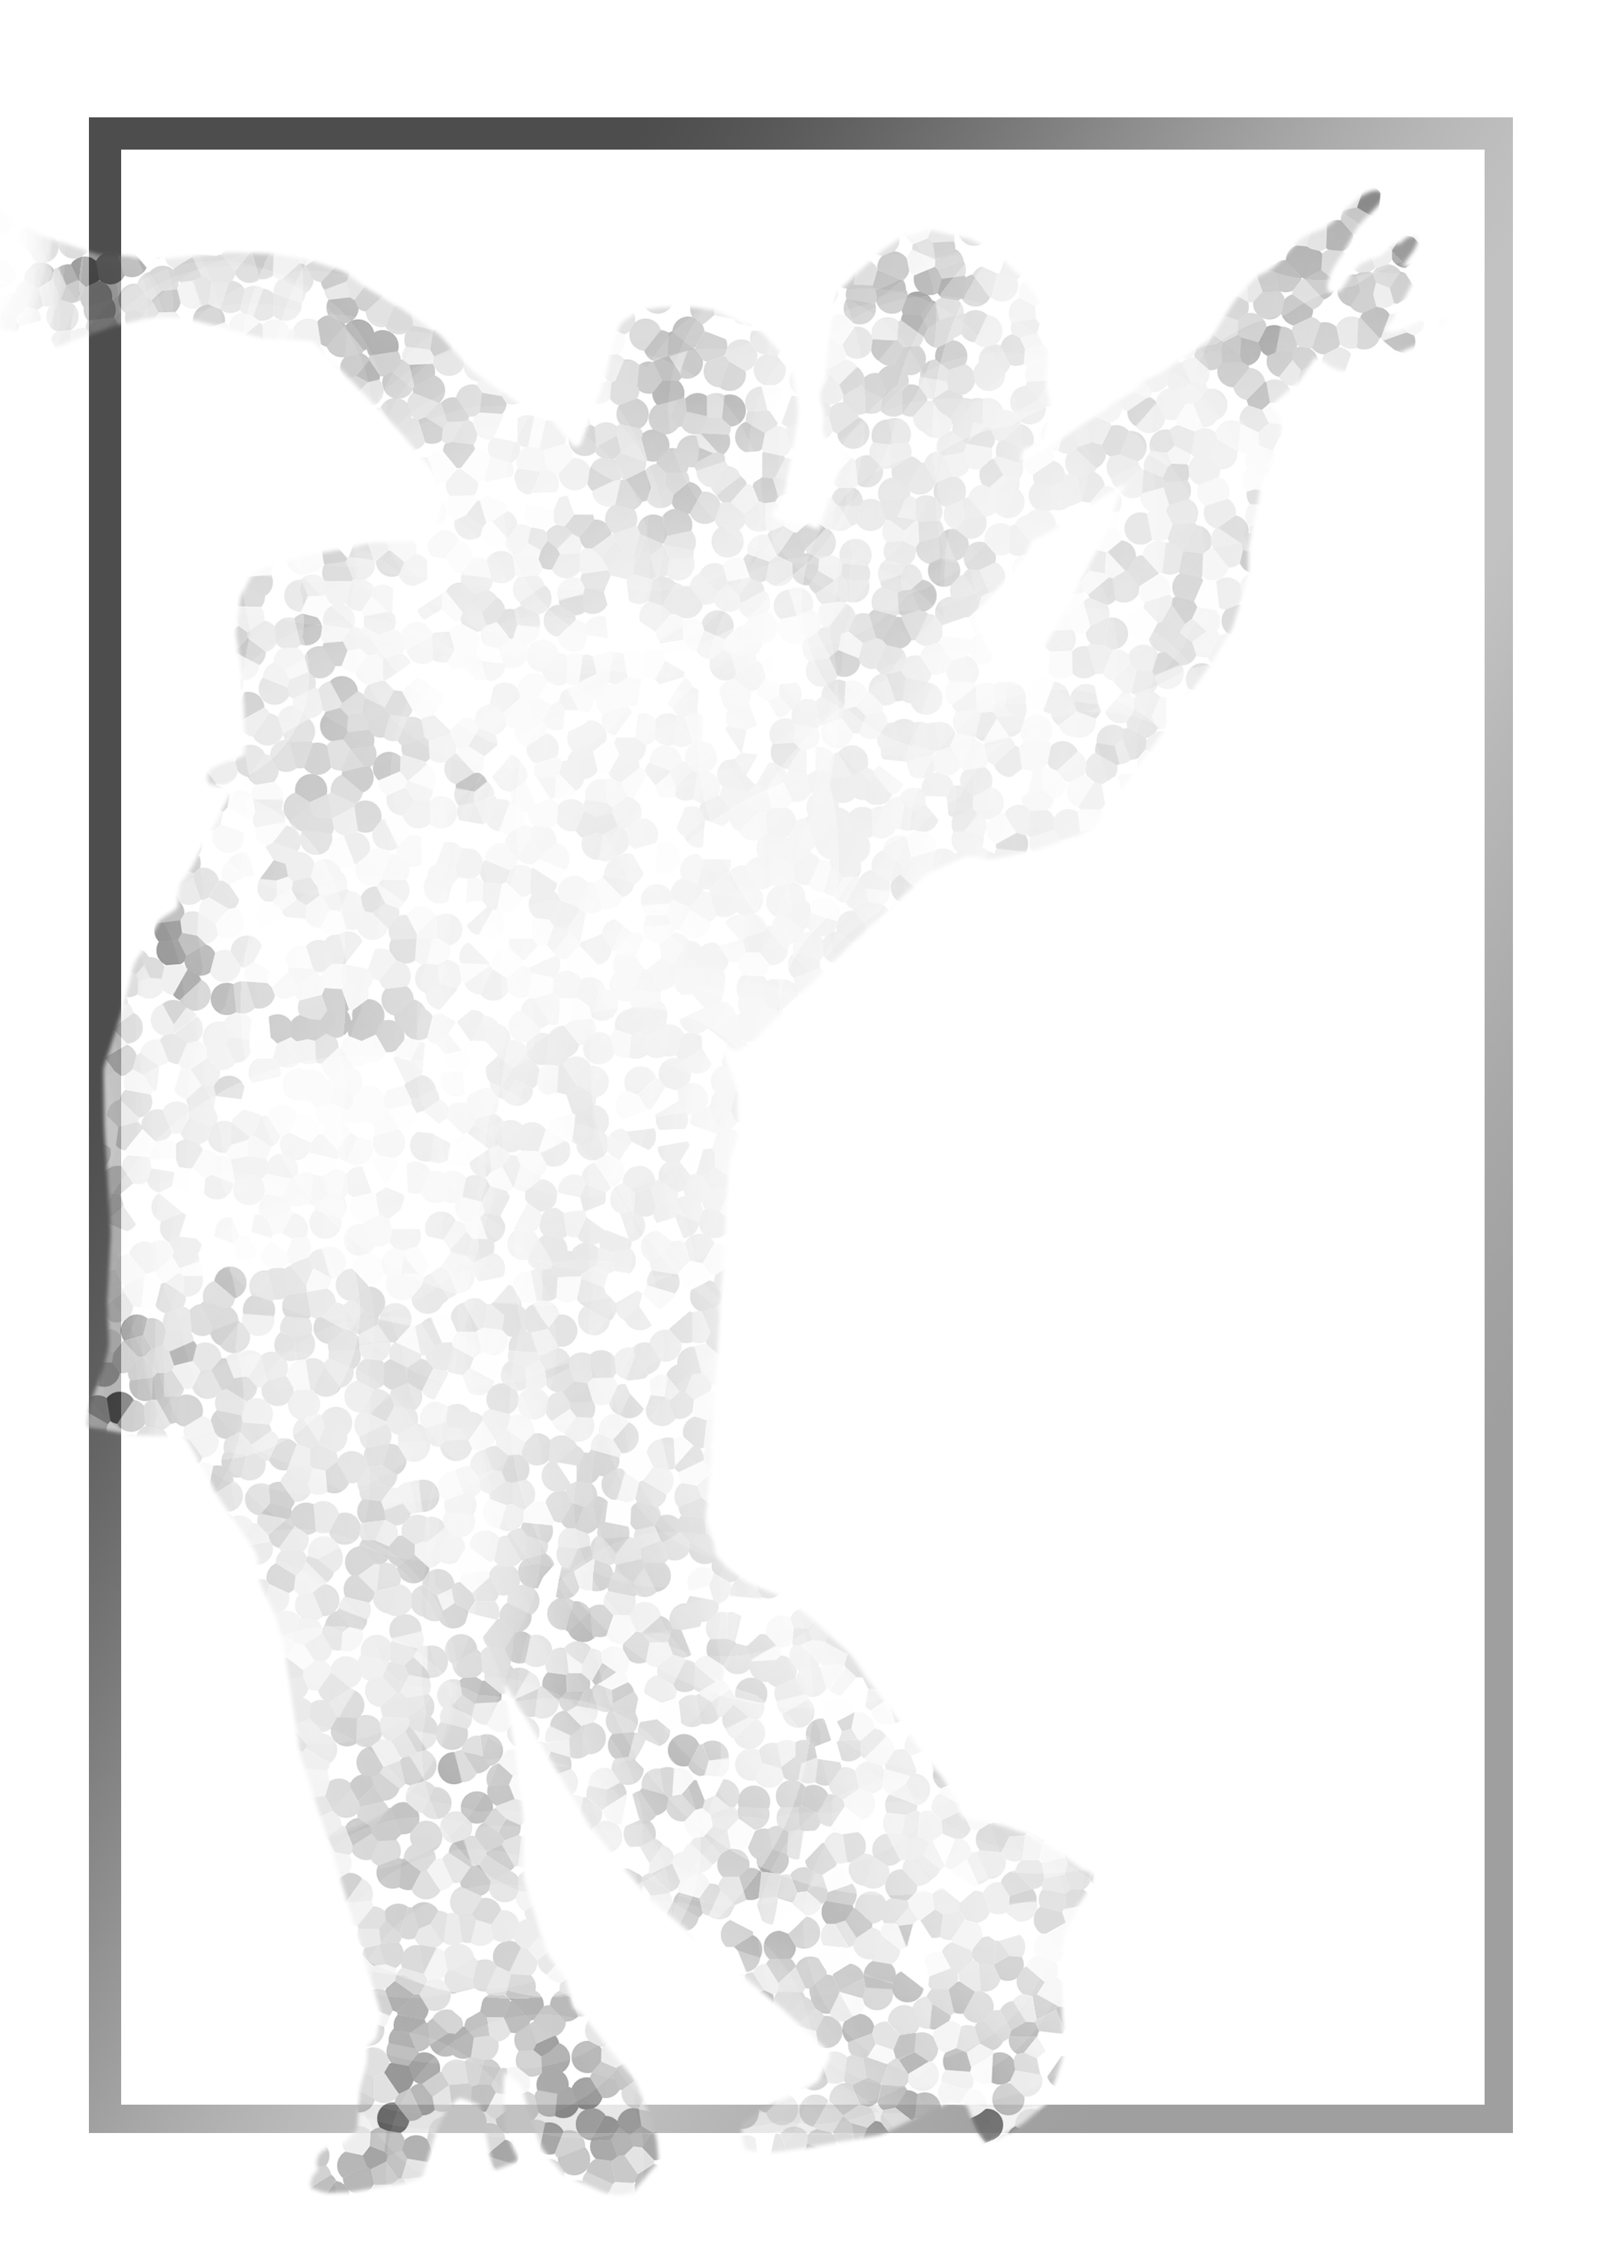

21st SGDF Singapore
National DanceSport
Championships

Saturday 16 March 2019
National University of Singapore Society (NUSS),
Kent Ridge Guild House,
9 Kent Ridge Drive,
Singapore 119241

Organised by:

Singapore DanceSport Federation

21st SGDF SINGAPORE NATIONAL DANCESPORT CHAMPIONSHIPS
Saturday 16 March 2019
National University of Singapore Society, Kent Ridge Guild House, 9 Kent Ridge Drive, Singapore 119241

Dear SGDF Member

The Singapore DanceSport Federation (SGDF) is pleased to present to you, the twentieth (21st) in a series of local ranking championships.

TITLE: | 21st SGDF Singapore National DanceSport Championships
DATE: | Saturday 16 March 2019
TIME: | 12pm – 6pm (tentative)
PLACE: | National University of Singapore Society (NUSS)  Kent Ridge Guild House,  9 Kent Ridge Drive,  Singapore 119241
ORGANISER: | Singapore DanceSport Federation  P O Box 0280 Tanjong Pagar Post Office  Singapore 910810  Tel: +65-6336-5339  Email: sgdf@dancesport.org.sg Web: www.dancesport.org.sg

EVENTS: The following events will constitute the Championships:

SGDF Categories | Standard | Latin
SGDF Grade A | W, T, VW, SF & Q | S, C, R, P & J
SGDF Grade A (Closed) | W, T, VW, SF & Q | S, C, R, P & J
SGDF U-21 Grade A | W, T, VW, SF & Q | S, C, R, P & J
SGDF Grade B | W, T, F & Q | S, C, R & J
SGDF Grade C | W, T & Q | C, R & J
SGDF Grade D | W & T | C & R
SGDF Grade E | W or T or Q | C or R or J
SGDF Junior Grade B | - | S, C, R & J
SGDF Junior Grade C | W, VW & Q | -
SGDF Juvenile II Grade D | - | C & J
SGDF Juvenile I Grade D | - | C & J
SGDF Junior Solo Girls | - | S or C or R or J
SGDF Juvenile Solo Girls | - | S or C or R or J
Affiliate ADP Categories | Standard | Latin
ADP Solo Ladies (16 years and above) | - | C or R or J
ADP Juvenile Grade D (13 years & below)  ADP Juvenile Grade E (11 years & below) | - | (C & J) or (S & R)  C or J
ADP Junior Solo Girls (12 years – 15 years) | - | (C & J) or (S & R)
ADP Juvenile Solo Girls (11 years & below) | - | (C & J) or (S & R)
SGDF Open Single Dance | Standard | Latin
SGDF Open Single Dance | W / T / VW / SF / Q | S / C / R / P / J

ADJUDICATORS: A panel of local and overseas adjudicators will be invited

PRIZES: Attractive medals and certificates will be awarded

ENTRY FEES: |  | 1st Event | Subsequent Event | Single Dance*
 | SGDF Members | S$40 (per person) | S$30 (per person) | S$10 (per person)
 | Overseas Competitors | S$50 (per person) | S$30 (per person) | S$10 (per person)
* Refer to Rule 22

TICKETS: S$50 for spectators, including buffet lunch

CHAMPIONSHIP RULES

1. All competitors must be valid members of the Singapore DanceSport Federation or affiliate. Your membership for FY19 (ie 1 April 2019 – 31 March 2020) must be paid up by Saturday 16 February 2019 (Closing date for entries). Overseas Competitors must be valid members of their local WDSF member federation.

2. The Championship Organisers reserves the right to refuse entries from persons whose status is unclear according to SGDF Rules.

3. No change of partner is allowed in the same event.

4. All competitors must attend rehearsals as requested by the Championship Organisers.

5. All competitors must be present for their events on time. Late-comers will be disqualified.

6. The Championship Organisers reserves the right to change the programme of events without prior notice.

7. The Championship Organisers will not accept any liability, claims for injuries, damages or loss suffered by the competitors.

8. The judges’ decision shall be final.

9. In the event of any question or matter arising out of any point which is not expressively provided for in the rules, the Championship Organisers shall have the power to use its own discretion.

- Age limits are taken during the calendar year 2019 (based on WDSF / ADSF regulations) as follows:

Category | Year Of Birth |  | Category | Year Of Birth
Juvenile I  Juvenile II  Junior I  Junior II | 2010 or later  2008 or 2009  2006 or 2007  2004 or 2005 |  | U-21  Adult | 1999, 2000, 2001, 2002, 2003  2000 or before

Putting two age groups together, such as Juvenile I and II (2008, 2009, 2010 or later) as well as Junior I and II (2004, 2005, 2006, 2007) to one joint age group, is an option under Rule E-2. Junior I couples are allowed to compete in Junior II, Junior II couples are allowed to compete in U-21, U-21 couples and Senior couples are allowed to compete in competitions of the Adult age group if they want.

In all age groups one partner of a couple can be younger.

11. All competitors must be dressed in appropriate costumes as specified in the WDSF Dress Regulation. The complete Competition Rules can be found at www.worlddancesport.sg.

Juvenile I and Juvenile II athletes (excl Solo Girls’) are to take note of the costume and makeup regulation as defined in the WDSF Dress Regulation.

12. For ADP and Closed Events

- ADP Events: both dancers MUST be members of the Athlete Development Programme (ADP)
- SGDF Closed: only for members of the SGDF and the affiliates

13. The Championship SGDF events will be grouped into the following bands:

Band 1: Grade A & Grade B
Band 2: Grade C & Grade D
Band 3: Grade E

Competitors are permitted to participate in events within one band only per category. For example:

SGDF Latin Grade C (Band 2) and SGDF Latin Grade D (Band 2) - permitted
SGDF Latin Grade B (Band 1) and SGDF Latin Grade C (Band 2) - not permitted
SGDF Latin Grade B (Band 1) and SGDF Standard Grade D (Band 2) - permitted

The bands are not applicable for participation in ADP and Solo Girls’ events.

14. Athletes in Grade E & Juvenile events must only dance restricted syllabus for both SGDF and ADP events.

15. All female athletes must wear heel protectors. Failure to wear them may result in disqualification.

16. Please write in block letters in the entry form, and ensure that all required information is filled in. The Organisers will not be responsible should there be a delay in your entry confirmation due to incomplete forms.

17. Other than the Closed events, all other events are “OPEN” to WDSF members of Malaysia and Vietnam.

18. Grade E participants may register for all dances offered eg you may register for SGDF Latin Grade E Cha, SGDF Latin Grade E Rumba & SGDF Latin Grade E Jive.

19. Please include the Entry Fee when submitting your Entry Form. If payment is by cheque, please address the cheque to “Singapore DanceSport Federation”.

20. For ADP Events, participants must be members of SGDF or its affiliates, or a member of the ADP.

21. Athletes who have participated in events outside the WDSF Competition System in the past 12 (twelve) months (ie 16 Mar 2018 – 16 Mar 2019), are not eligible.

22. For SGDF OPEN SINGLE DANCE EVENTS:

- the minimum age group for both dancers will be taken as U-21 (ie born with reference Rule 10 above)

- participants must be registered in at least one Grade A or one Grade B to be eligible to register for Open Single Dance events

- there is no limit to the number of Single Dance events that athletes can register.
SINGAPORE DANCESPORT FEDERATION
21st SGDF Singapore National DanceSport Championships

Date:
Gentleman | Lady
Name: | Name:
Address: | Address:
Contact No: | Contact No:
E-mail: | E-mail:
Date of Birth: (Day/Month/Year): | Date of Birth: (Day/Month/Year):
NRIC / Passport No: | NRIC / Passport No:
Signature: | Signature:

We wish to participate in the following events (please tick  ):

SGDF EVENTS
STANDARD CATEGORIES | LATIN CATEGORIES
 SGDF Grade A (W, T, VW, SF, Q)   SGDF Grade A (Closed) (W, T, VW, SF, Q)   SGDF U-21 Grade A (W, T, VW, SF, Q)   SGDF Grade B (W, T, SF, Q)   SGDF Grade C (W, T, Q)   SGDF Grade D (W, T)   SGDF Grade E* (W)   SGDF Grade E* (T)   SGDF Grade E* (Q)   SGDF Junior Grade C (W, VW, Q) |  SGDF Grade A (S, C, R, P, J)   SGDF Grade A (Closed) (S, C, R, P, J)   SGDF U-21 Grade A (S, C, R, P, J)   SGDF Grade B (S, C, R, J)   SGDF Grade C (C, R, J)   SGDF Grade D (C, R)   SGDF Grade E* (C)   SGDF Grade E* (R)   SGDF Grade E* (J)   SGDF Junior Grade B (S, C, R, J)   SGDF Juv ll Grade D* (C, J) born in 2008, 2009   SGDF Juv I Grade D* (C, J) born in 2010 or later   SGDF Junior Solo Girls (S) }   SGDF Junior Solo Girls (C) } born in   SGDF Junior Solo Girls (R) } 2004, 2005, 2006, 2007   SGDF Junior Solo Girls (J) }   SGDF Juv Solo Girls (S) }   SGDF Juv Solo Girls (C) } born in   SGDF Juv Solo Girls (R) } 2008,2009, 2010 & later   SGDF Juv Solo Girls (J ) }

ADP LATIN EVENTS
 ADP Solo Ladies (C) 16 years & above   ADP Solo Ladies (R) 16 years & above   ADP Solo Ladies (J) 16 years & above   ADP Juvenile Grade D (C, J) 13 years & below   ADP Juvenile Grade D (S, R) 13 years & below   ADP Juvenile Grade E* (C) 11 years & below   ADP Juvenile Grade E* (J) 11 years & below |  ADP Junior Solo Girls (C, J) 12 years – 15 years   ADP Junior Solo Girls (S, R) 12 years – 15 years   ADP Juvenile Solo Girls (C, J) 11 years & below   ADP Juvenile Solo Girls (S, R) 11 years & below

SGDF OPEN SINGLE DANCE CATEGORIES
STANDARD CATEGORIES | LATIN CATEGORIES
 SGDF Open Single Dance Waltz   SGDF Open Single Dance Tango   SGDF Open Single Dance Viennese Waltz   SGDF Open Single Dance Slow Foxtrot   SGDF Open Single Dance Quickstep |  SGDF Open Single Dance Samba   SGDF Open Single Dance Cha-Cha-Cha   SGDF Open Single Dance Rumba   SGDF Open Single Dance Paso Doble   SGDF Open Single Dance Jive

* - Restricted Syllabus

CLOSING DATE: Saturday 16 February 2019 (Please Attach Entry Fee)
By signing this form, both participants would have deemed to agree to the Championship Rules.
Ver 1.2

