

Date: | 20 September 2009 (Sunday)
Venue: | Queen Elizabeth Stadium  (18 Oi Kwan Road, Wanchai, Hong Kong)
Organizer: | Hong Kong DanceSport Association Limited
Events: | (1) 2009 Hong Kong IDSF Open (Latin)  (2) 2009 Hong Kong IDSF Open (Standard)
Discipline: | 5 dances respectively for Latin & Standard
Adjudicators: | A panel of IDSF Licensed Adjudicators
Accommodation: | Two-night (19 & 20 September 2009) free accommodation (a maximum of 2 couples per event per country) including breakfast will be provided at the Official Hotel to international competitors.  (For more than 2 couples and for coaches / team leaders, hotel will be at their own expenses)
Official Hotel: | Caritas Oswald Cheung International House  Address: 20 Tin Wan Street, Tin Wan, Aberdeen , Hong Kong.  Tel: +852 2903 0263 / +852 2903 0264 Fax: +852 2903 0101  Email: cocih@caritas-chs.org.hk  Website: http://www.caritas-chs.org.hk/eng/index.asp
Transportation: | The Organizer provides transportation between Hong Kong International Airport / Official Hotel / Event Venue (competitors & officials only)
Traveling expenses: | The Organizer does not pay any traveling expenses
Tickets: | Couples are only allowed to enter Event Venue during competition.  Couples can contact Organizer in advance for ticket purchase for other events
Entry Fee: | US$40 (or HK$320) per event per couple
Registration: | Please fill in the Entry Form and send it to couples’ representing federation for registration. (Only IDSF registered couples are accepted)
Entry Deadline: | 10 August 2009
Enquiries: | Hong Kong DanceSport Association Limited  Tel: +852 3571 9829 Fax: +852 2312 1196  Address: Rm 809, 8/F, New Kowloon Plaza, 38 Tai Kok Tsui Rd, Kowloon, Hong Kong  Website: www.dancesport.org.hk Email: dancesport2009@gmail.com

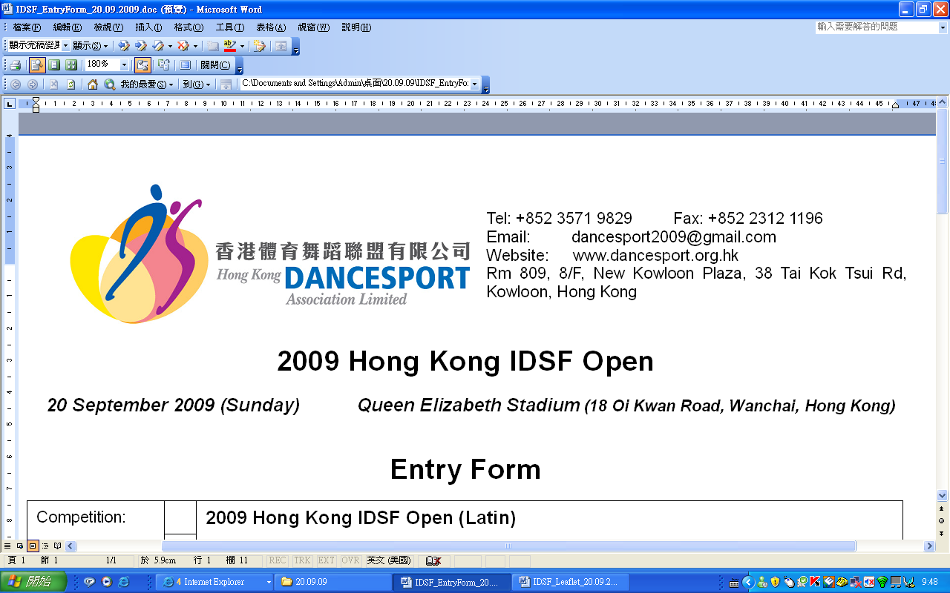
Entry Form
Event: |  |  | 2009 Hong Kong IDSF Open (Latin)
(Pls put x in □) |  |  | 2009 Hong Kong IDSF Open (Standard)
Representing Country:
Member Association:
Gentleman |  |  |  | Lady
Family name:  First name: |  |  |  | Family name:  First name:
Address: |  |  |  | Address:
Tel: |  |  |  | Tel:
Email: |  |  |  | Email:
Date of birth: |  |  |  | Date of birth:
Passport / ID No.: |  |  |  | Passport / ID No.:
Nationality: |  |  |  | Nationality:
Need invitation letter for visa: Yes / No |  |  |  | Need invitation letter for visa: Yes / No
Signature: |  |  |  | Signature:
Date:

Entry Deadline: 10 August 2009

- Entry fee: US$40 (or HK$320) per couple per event.
- For international couples, entry fee to be paid upon arrival of Official Hotel.
- For Hong Kong couples, please send cheque payable to “Hong Kong DanceSport Association Limited” on or before 10 August 2009.
- Please email this entry form with 1 colour action photo to couples’ representing federation for registration.
For enquiries:

Hong Kong DanceSport Association Limited

Address: Room 809, 8/F, New Kowloon Plaza, 38 Tai Kok Tsui Road, Kowloon, Hong Kong
Fax: +852 2312 1196 Email: dancesport2009@gmail.com
Tel: +852 3571 9829 Website: www.dancesport.org.hk

Release of All Claims
In the event of Television coverage or production of a Video Recording for commercial purposes of any part of the competitions, we agree that the rights to any fee for such television or video recording will vest solely with the Organizer and no competitor shall have any claim against the Organizer, Television Company or Video Producer at any such event.
(Version 2009.06.18)

