

The 3rd King’s Cup Thailand Open 2012
(WDSF International Open Standard & Latin)
4th & 5th August 2012

Entry Form

Date of Entry :
Country of Representation :
Member Federation :
  Standard
   | WDSF International Open | 5 Dances
   | ADSF Adult Open | 5 Dances
   | Youth Open | 5 Dances
   | Junior II Open | 5 Dances
   | Junior I Open | 5 Dances
   | Juvenile II Open | 5 Dances
   | Juvenile I Class C | W,T&Q
   | Senior Open | 5 Dances
  Latin American
   | WDSF International Open | 5 Dances
   | ADSF Adult Open | 5 Dances
   | Youth Open | 5 Dances
   | Junior II Open | 5 Dances
   | Junior I Open | 5 Dances
   | Juvenile II Open | 5 Dances
   | Juvenile I Class C | C,R&J
   | Senior Open | 5 Dances
Gentleman | Lady
Family Name : | Family Name :
First Name : | First Name :
Nationality : | Nationality :
Date of Birth :  (Day/Month/Year) | Date of Birth :  (Day/Month/Year)
Passport No: | Passport No:
Tel No : | Tel No :
Fax No : | Fax No :
E-mail : | E-mail :
Signature : | Signature :

Closing Date of Entries: 1th July 2012

Release of All Claims
In the event of Television coverage of production of a Video Recording for commercial purposes of any part of the competitions, we agree that the rights to any fee for such television or video recording will vest solely with the Organizer and no competitor shall have any claim against the Organizer, Television Company or Video Producer at any such event.

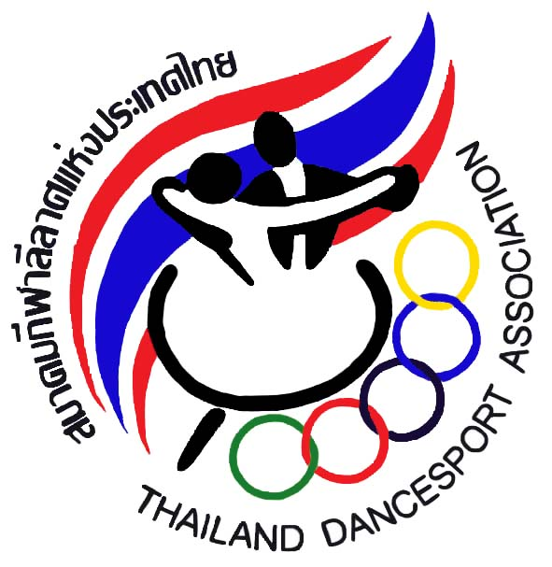
Please send your Entries to :
Thailand DanceSport Association 95 Yenchit rd., Toong Watdon, Sathorn District, Bangkok, Thailand 10120
Telephone : (662)675-9776-8 Fax : (662) 675-9779 E-mail : tdsa_sat@yahoo.com
The 3rd King’s Cup Thailand Open 2012
(WDSF International Open Standard & Latin)
4th & 5th August 2012

RULES

- All competitors must be a member of their respective WDSF member associations.
- ADSF adult open are only to member countries of Asian DanceSport Federation (ADSF)
- All local competitors must be a member of Thailand DanceSport Association (TDSA)
- No change of partner is allowed in the same event.
- All competitors must be dressed in their appropriate costumes as specified in the WDSF Dress Regulations.
- Advertising on competition dress is allowed subject to WDSF Rules.
- All competitors must attend rehearsals as requested by the Organizer.
- All competing couples must be present 15mins. before their events. Late comers will be disqualified.
- The WADA Rules on doping shall apply.
- The Organizer reserves the right to change the program of events without prior notice.
- The Organizer will not accept any liability, claims for injuries, damage or loss suffered by the competitors.
- The judges’ decision shall be final
- In the event of any question or matter arising out of any point which is not expressively provided for in the Rules of the Championships, the organizer shall have the power to use its own discretion.
- In the events of television coverage of production of video recording for commercial purposes of any competitions event, all competitors must agree that the right to any fees from such television or video recording rest solely with the organizers and no competitors or associations shall have any claims against the organizers.
- The 3rd “King’s Cup” Thailand Open 2012 will be conducted in accordance with the latest version of rules and regulations of the World DanceSport Federation (WDSF)
- Age Restriction is according to WDSF competition Rules 11
Juvenile - both dancers must be born in 2001 or later
Junior I - both dancers must be born in 1999 or 2000
Junior II - both dancers must be born in 1997 or 1998
*Youth - both dancers must be born in 1994, 1995 or 1996
Adult - both dancers must be born in 1993 or earlier
Senior - both dancers must be born in 1977 or earlier
*Youth couples are allowed to compete in Adult competitions.
17. Restrictions of Syllabus Rules 15 of WDSF for all Juvenile event(s) shall apply.

Please send your Entries to :
Thailand DanceSport Association 95 Yenchit rd., Toong Watdon, Sathorn District, Bangkok, Thailand 10120
Telephone : (662)675-9776-8 Fax : (662) 675-9779 E-mail : tdsa_sat@yahoo.com

