


Entry Form
Country :
Member Federation :
Gentleman |  | Lady
Surname : |  | Surname :
Given Name : |  | Given Name :
Date of Birth :  DD/MM/YYYY |  | Date of Birth :  DD/MM/YYYY
ID No : |  | ID No :
Passport No : |  | Passport No :
Contact No : |  | Contact No :
E-Mail : |  | E-Mail :
Address: |  | Address :
Standard | ✓ | Latin | ✓
Single Dance - Waltz |  | Single Dance - Samba
Single Dance - Tango |  | Single Dance - Cha Cha Cha
Single Dance - V. Waltz |  | Single Dance - Rumba
Single Dance - Slow Foxtrot |  | Single Dance - Paso Doble
Single Dance - Quickstep |  | Single Dance - Jive
Adult Open (5 Dances) |  | Adult Open (5 Dances)
Junior I Class C Open (W,T & Q) |  | Junior I Class C Open (C,R & J)
Junior II Class C Open (W,T & Q) |  | Junior II Class C Open (C,R & J)
Juvenile II Class C Open (W,T & Q) |  | Juvenile II Class C Open (C,R & J)
Senior Class C Open (W,T & Q) |  | Senior Class C Open (C,R & J)

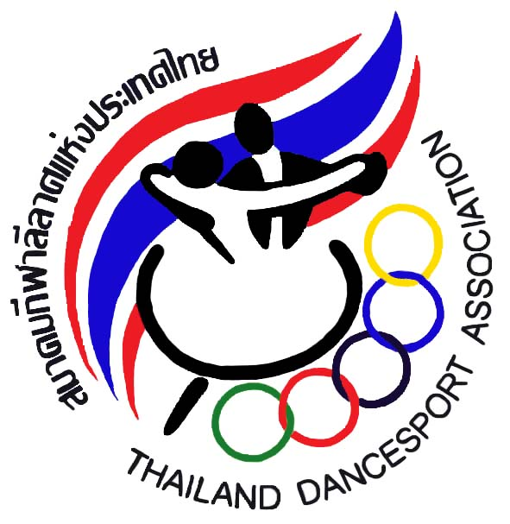
Thailand DanceSport Association
95 Yenchit rd., Toong Watdon, Sathorn District, Bangkok, Thailand 10120
Telephone : (662)675-9776-8 Fax : (662) 675-9779 E-mail : tdsa_sat@yahoo.com

Rules
- All competitors must be a member of their respective ADSF member association.
- All national competitors must be a member of Thailand DanceSport Association (TDSA).
- No change of partner is allowed in the same event.
- All competitors must be dressed in their appropriate costumes as specified in the
WDSF Dress Regulations.
- Advertising on competition dress is allowed subject to WDSF Rules.
- All competitors must attend rehearsals as requested by the Organizer.
- All competing couples must be present 15mins. Before their events. Late comers
will be disqualified. The WADA Rules on doping shall apply.
- The Organizer reserves the right to change the program of events without prior notice.
- The Organizer will not accept any liability, claims for injuries, damage or loss suffered
by the competitors.
- The judges decision shall be final.
- In the event of any question or matter arising out of any point which is not expressively provided for in the Rules of the Championships, the organizer shall have the power to use its own discretion.
- In the events of television coverage of production of video recording for commercial purposes of any competitions event, all competitors must agree that the right to any fees from such television or video recording rest solely with the organizers and no competitors or associations shall have any claims against the organizers.
- TDSA(Open) & Asian Single Dance Championship 2012 will be conducted in accordance with the latest version of the rules and regulations of the World DanceSport Federation (WDSF)
- Age Restriction is according to WDSF competition Rules 11
Juvenile - both dancers must be born in 2001 or later
Junior I - both dancers must be born in 1999 or 2000
Junior II - both dancers must be born in 1997 or 1998
*Youth - both dancers must be born in 1994, 1995 or 1996
Adult - both dancers must be born in 1993 or before
Senior - both dancers must be born in 1977 or before
*Youth couples are allowed to compete in Adult competitions
15. Restrictions of Syllabus Rules 15 of WDSF for all Juvenile event(s) shall apply.

Additional Rules (Asian Single Dance)
1. The Asian Single Dance will be conducted in accordance with the latest version of Rules and Regulation of the Asian DanceSport Federation (ADSF)
2. Each ADSF member country can be represented by a maximum 4 couples.
3. Each couple can enter to a maximum of 3 competitions (events).
4. Each ADSF member federation can enter a maximum of 1 couple for each competition (event)
Thailand DanceSport Association
95 Yenchit rd., Toong Watdon, Sathorn District, Bangkok, Thailand 10120
Telephone : (662)675-9776-8 Fax : (662) 675-9779 E-mail : tdsa_sat@yahoo.com

Updated Information
Dear Sir/Madam
We wish to inform you about some of the information that was omitted in our Entry form and Rules pertaining to the above championship.

- All competitors participating in the Asian Single Dance & TDSA Adult Open only will be provided with 3 nights stay (27th, 28th & 29th April) in our official hotel which is Grand Mercure Fortune, Bangkok.
- The entry fee is applicable to all Open Events only. Couples participating in the Asian Single Dance need not pay any entry fee. The entry fee is US$60 per couple.
- The venue is at Bangkok Metropolitan Center (Gymnasium 1) Dindeang, Bangkok.
- All team leaders, coaches, supporters that would like to stay at the official hotel must book thru the organizer. Any couples that like to have an extension of stay must also inform the organizer. The special room rate is US$70/2,200baht per night inclusive of breakfast.
- The prize money offer to the TDSA Adult Open Only is as follows:-
Champion US$600.00
1st Runner-up US$400.00
2nd Runner-up US$200.00
4th – 6th Placing US$100.00
- The Closing date for all entries is on 31st March, 2012.
We sincerely apologize for any inconvenience caused.
Yours sincerely

Sittichai Preyadara
General Secretary
Thailand DanceSport Association
95 Yenchit rd., Toong Watdon, Sathorn District, Bangkok, Thailand 10120
Telephone : (662)675-9776-8 Fax : (662) 675-9779 E-mail : tdsa_sat@yahoo.com

