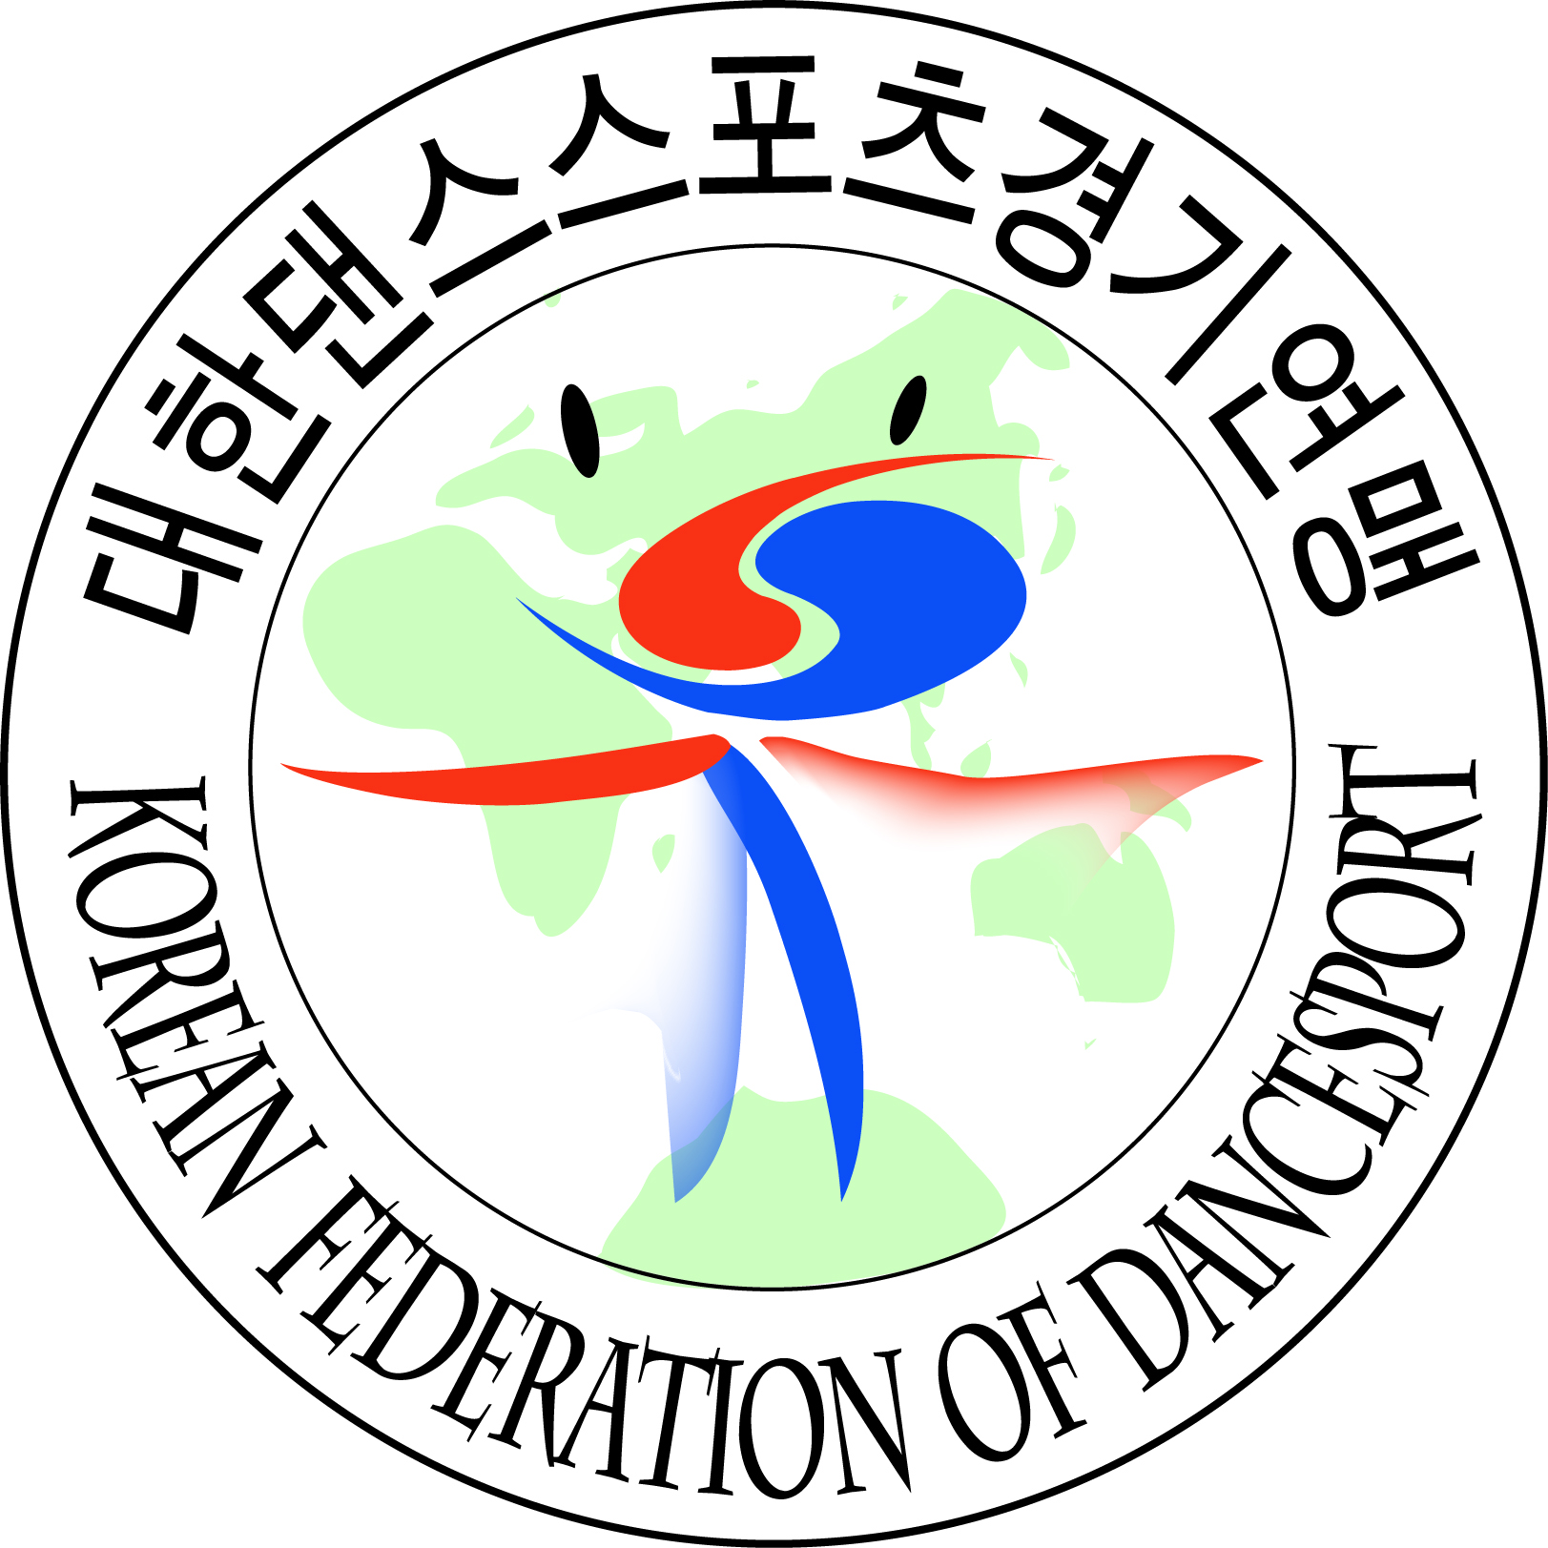 | WDSF International Open  Standard & Latin DanceSport  Championship |  | 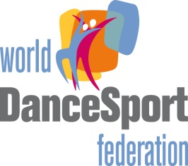
Date : |  | 6th May 2012(Sunday)
Venue : |  | SK Hanball Gym, Olympic Park, Oryung-Dong, Songpa-Gu, Seoul, Korea
Organizer : |  | Korean Federation of DanceSport(KFD)
 |  | 88-2 SK Handball Gym. Room 119. Oryung-Dong, Songpa-Gu, Seoul, Korea
 |  | Tel : +82-2-415-2090~1 Fax : +82-2-415-2050
 |  | E-mail : kfd2050@naver.com
Adjudicator : |  | An international Panel of adjudicators will be nominated by WDSF and KFD
Title : |  | 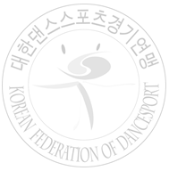  WDSF International Open Standard & Latin
Attractive cash prizes for the following events (Currency: Euro)
EVENTS | 1st | 2nd | 3rd | 4th~6th
WDSF International Open Standard | 1,800 | 1,300 | 1,000 | 800, 700, 600
WDSF International Open Latin | 1,800 | 1,300 | 1,000 | 800, 700, 600

Official Hotel : |  | Olympic Parktel
 |  | #88-8, Bangyi-Dong, Songpa-Gu, Seoul, Korea.
 |  | Tel : +82-2-410-2114 E-mail : ptd@ksto.or.kr website : www.parktel.co.kr
Accommodation : |  | Hotel Accommodation for 2 nights will be provided for overseas couples.(From 5 to 6 MAY)
The special price will be provided for accompanying persons, coaches.
(App. USD100 per one night).
Transportation : |  | The organizer provides transportation between Airport ↔Hotel and Hotel↔Venue.
Travel Expenses : |  | The organizer does not pay any travel expense.
Entry Fee : |  | 30 Euro per couple
Closing Date : |  | 6 Apr 2012
We are looking forward to your participation

Dr. Yoon-Bang KWON
President
Korean Federation of DanceSport(KFD)

WDSF International Open DanceSport Championships
Official Entry Form

Date:

Country: Member Association:

Gentleman | Lady
Name: | Name:
Address: | Address:
Tel No: | Tel No:
Fax No: | Fax No:
E-mail: | E-mail:
Date of Birth: (Day/Month/Year): | Date of Birth: (Day/Month/Year):
Passport No: | Passport No:
Signature: | Signature:

We wish to participate in the following events (please tick):

Category | Standard | Latin
2012 WDSF International Open

CLOSING DATE : 6 Apr 2012

Please enclose one clear copy of color action photograph

By signing this form, both participants would have deemed to agree to the WDSF Championship Rules and to participate in the opening ceremony.

Korean Federation of DanceSport, KFD
88-2 SK Handball Gym. Room 119, Oryun-Dong, Songpa-Gu, Seoul, Korea
Tel:+82-2-415-2090 Fax: +82-2-415-2050
Email:kfd2050@naver.com

