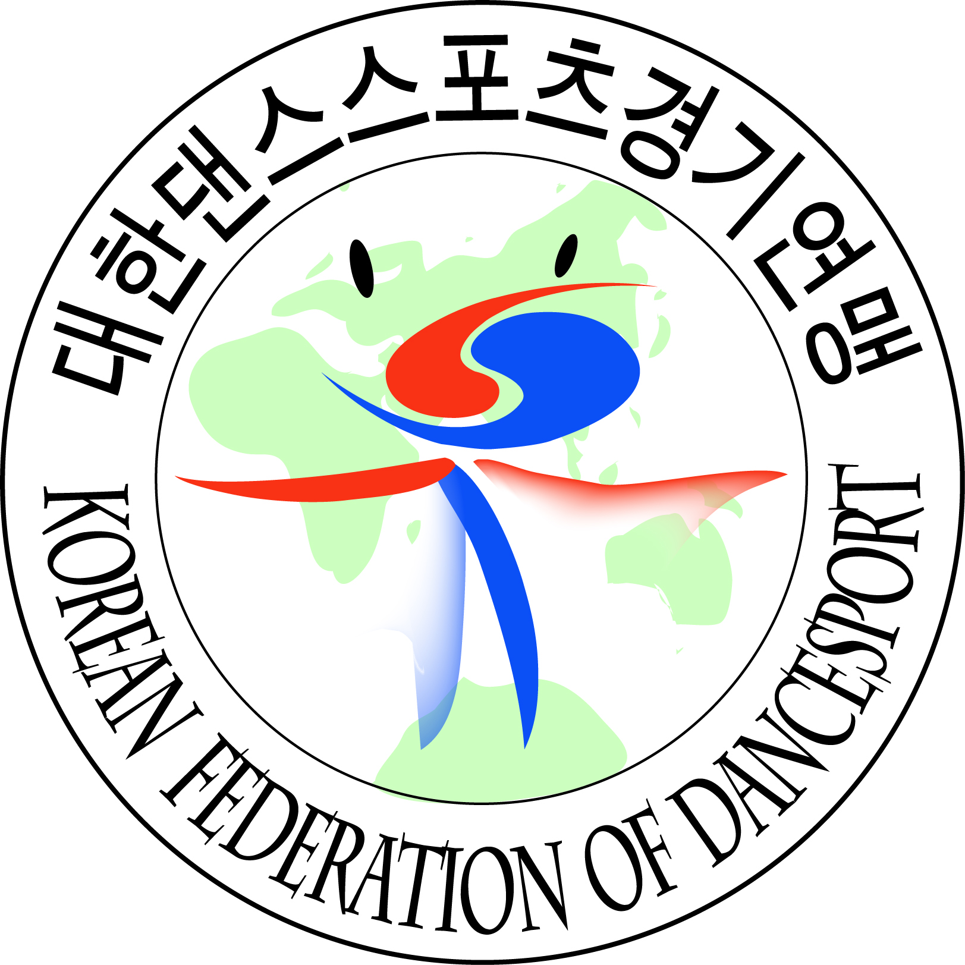 | WDSF World Open Standard & Latin DanceSport Championship |  | 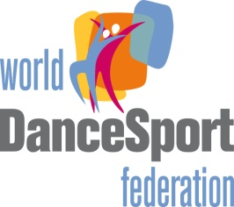
Date : |  | 20^{th ~} 21th Apr 2013(Saturday and Sunday)  20.APR.2013(SAT) : WDSF World Open Latin  21.APR.2013(SUN) : WDSF World Open Standard
Venue : |  | SamSan World Gym, 458-1 Samsan-2 dong, Bupyeong-Gu, Incheon, Korea
Organizer : |  | Korean Federation of DanceSport(KFD)
 |  | 88-2 SK Handball Gym. Room 119. Oryung-Dong, Songpa-Gu, Seoul, Korea
 |  | Tel : +82-2-415-2090~1 Fax : +82-2-415-2050
 |  | E-mail : kfd2050@naver.com
Adjudicator : |  | An international Panel of adjudicators will be nominated by WDSF and KFD
Title : |  | 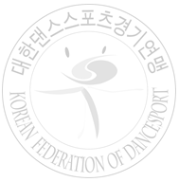  WDSF World Open Standard & Latin
Attractive cash prizes for the following events (Currency: Euro)
EVENTS | 1st | 2nd | 3rd | 4th~6th
WDSF World Open Standard | 2,000 | 1,500 | 1,000 | 800, 700, 600
WDSF World Open Latin | 2,000 | 1,500 | 1,000 | 800, 700, 600

Official Hotel : |  | Best Western Premier Songdo Park Hotel
 |  | 151, Techno park-ro, Yeonsu-gu, Incheon, Korea.
 |  | Tel : +82-32-210-7000 website : www.songdoparkhotel.com/eng/common/main.asp
Accommodation : |  | Hotel Accommodation with breakfast for 2 nights will be provided for overseas couples.
The special price will be provided for accompanying persons and coaches.
(App. USD 95 per one night).
Transportation : |  | The organizer provides transportation between Airport ↔Hotel and Hotel↔Venue.
Travel Expenses : |  | The organizer does not pay any travel expense.
Entry Fee : |  | 30 Euro or 45,000 Korean Won per couple.
Closing Date : |  | 6 Apr 2012
We are looking forward to your participation
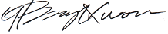
Dr. Yoon-Bang KWON
President
Korean Federation of DanceSport(KFD)

WDSF World Open DanceSport Championships
Official Entry Form

Date:

Country: Member Association:

Gentleman | Lady
Name: | Name:
Address: | Address:
Tel No: | Tel No:
Fax No: | Fax No:
E-mail: | E-mail:
Date of Birth: (Day/Month/Year): | Date of Birth: (Day/Month/Year):
Passport No: | Passport No:
Signature: | Signature:

We wish to participate in the following events (please tick):

Category | Standard | Latin
2013 WDSF World Open

CLOSING DATE : 6 Apr 2012

Please enclose one clear copy of color action photograph

By signing this form, both participants would have deemed to agree to the WDSF Rules and to participate in the opening ceremony. In the event of Television coverage and photos of any part of competitions recorded by KFD, we agree that the rights to any fee for such television or photo recording will vest solely with KFD and no competitors, association and federation shall have any claim against KFD, Television Company and photographers at any such event.

Korean Federation of DanceSport, KFD
88-2 SK Handball Gym. Room 119, Oryun-Dong, Songpa-Gu, Seoul, Korea
Tel:+82-2-415-2090 Fax: +82-2-415-2050
Email:kfd2050@naver.com

