TDSA WDSF
Professional Division Open Dancesport Championships 2014

ENTRY FORM
Date of Entry :
Country of Representation :
Member Federation :
Standard  WDSF PD Open (5 Dance)  TDSA Adult Open (5 Dance)  Junior I+II Open (Class A) (5 Dance)  Juvenile I+II Open (Class C ) (W, T & Q)  Senior II Open (Class C) (W, T & Q) | Latin American  WDSF PD Open (5 Dance)  TDSA Adult Open (5 Dance)  Junior I+II Open (Class A) (5 Dance)  Juvenile I+II Open (Class C) (C, R & J)  Senior II Open (Class C) (C, R & J)
Gentleman | Lady
Family Name : | Family Name :
First Name : | First Name :
Nationality : | Nationality :
Date of Birth :  (Day/Month/Year) | Date of Birth :  (Day/Month/Year)
Passport No: | Passport No:
Tel No : | Tel No :
MIN No : | MIN No :
E-mail : | E-mail :
Signature : | Signature :

Closing Date of Entries: 4th April, 2014

Release of All Claims
In the event of Television coverage of production of a Video Recording for commercial purposes of any part of the competitions, we agree that the rights to any fee for such television or video recording will vest solely with the Organizer and no competitor shall have any claim against the Organizer, Television Company or Video Producer at any such event.

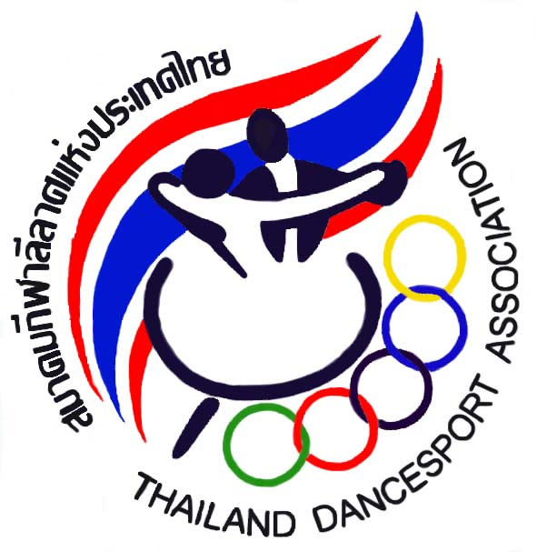
Thailand Dancesport Association [TDSA]
95 Yenchit Road, Toong Watdon, Sathorn District,Bangkok 10120 THAILAND
Tel :(662)675-9776-8, (662)675-9795 Fax: (662)675-9779 www.tdsa.or.th Email : tdsa_sat@yahoo.com

