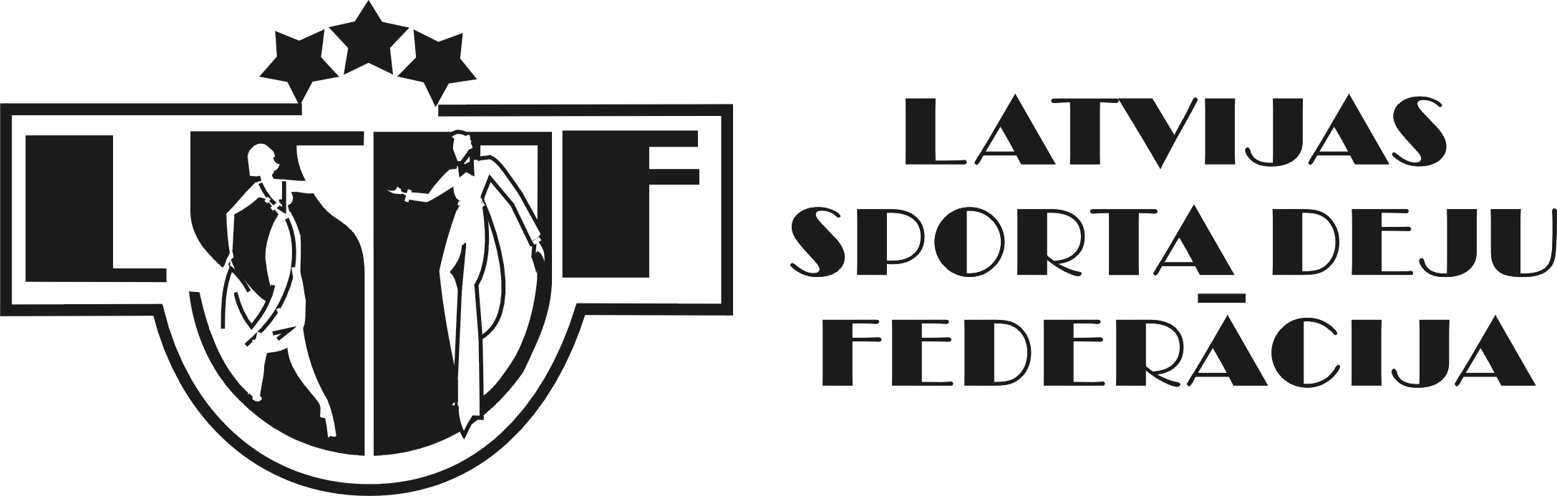
____________________________________________________________________________

Riga, July 1st, 2015

Dear Ladies and Gentlemen,

We cordially invite couples from your country to participate at:

WDSF World Championship Under 21 Ten Dance 2015

Date: October 31, 2015

Beginning: 14:00 (approx..)

Venue: “Daugavas Sporta nams”, 107 Kr. Barona str., Riga, Latvia

Organizer: Latvian DanceSport Federation (LDSF); Dance Sport Club “Mario”

Contact: Mobile: +371 29346154
E-mail: info@latviaopen.lv
Web: www.lsdf.lv; www.latviaopen.lv

Conditions: According to WDSF Rules

- Travel expenses including transfers from and to the airport and hotel accommodation must be paid by the couples.
- All couples advancing to the quarter-final of the Open World Championships shall be paid a lump sum according to WDSF Rules ( please, check www.latviaopen.lv for Air Baltic reduced air fares and hotel information).

We kindly ask you to send your entries to: jarajs@hotmail.com till: September 30, 2015

We would appreciate very much your accepting of this invitation and kindly request your notice on time also if not in affirmative.

Best regards,

Juris Arajs
LSDF General Secretary

